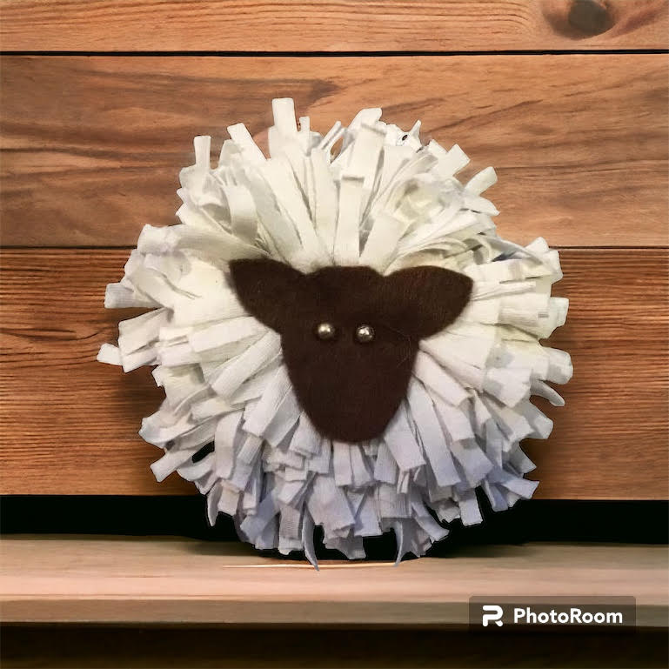



Ein Swyddfa,

11 Cambrian Place

Aberystwyth SY23 1NT

Secretary - Eirwen James Phone 01970 612 831

e-mail:ceredigion.wi@gmail.com

Open to members on Mondays

and Thursdays 10-1pm.

**Mai**

**2024**

**May**

**Gair gan y Cadeirydd / *Chairman’s Message,***

**Congratulations** to Penllwyn WI for receiving the 2023 NFWI Wales Recruitment  Award for WI’s with under 25 members. It is a fantastic achievement. The prize was accepted by President Judy Lile who attributed their success to ensuring a warm welcome at meetings and by producing an interesting and varied programme.

Llongyfarchiadau i Sefydliad y Merched Penllwyn, Rydym mor falch o’u llwyddiant. Dyma brofi bod cael rhaglen dda yn allweddol os am ddenu aelodau newydd.

Best wishes for the new WI year. Dymuniadau gorau yn y flwyddyn SyM newydd.

**Gay Evans**

**NFWI Resolution Second Vote 2023-24.**

The WI members have voted by a majority of some 10,000 votes for “Dental Health Matters” to go forward to the Annual Meeting in June. It is now time for each WI to decide whether or not it is for or against this resolution; that is, whether you wish to give NFWI a mandate to turn this resolution into a campaign (vote for) or reject it (vote against).

There are resources on My WI and in WI Life to help you decide and also a Webinar on 24th April on Zoom. Your WI has an appointed Delegate who will be present at the Annual Meeting and will vote on your behalf in accordance with your wishes. She will contact you soon.

At this meeting the Proposer, Seconder and experts in the field will present the pros and cons of the resolution following which the Delegates will be asked to vote. It is possible and indeed it has happened in the past, where evidence has been presented to the meeting that conflicts with the intent of the Resolution, and what may have started out as an excellent idea is now unsuitable for a campaign.

For this reason, you are asked to consider giving your Delegate “**Discretion**” to vote as she thinks fit after hearing the presentations. If you do not give her Discretion then she is duty bound to vote as you decided in your WI regardless of what transpires at the meeting.

Discretion could also apply if your WI voted against the Resolution and there was a strong case presented for it. If you have any queries regarding the above, please contact your Delegate, or Margaret Peel via Ein Swyddfa

**Annual Meeting Royal Albert Hall** – The CFWI visit to the Annual Meeting is around the corner.

We are looking forward to the three day event along with theatre trip and Houses of Parliament visit. Coach pick up times will be sent to all attending.

**200 CLUB** At a cost of £6 you, members of your family and friends have the opportunity to take part in the monthly draw of the CFWI 200 Club. Proceeds of this draw go towards the upkeep of Ein Swyddfa and a cheque is presented to the CFWI Treasurer in the Annual Council Meeting.

You can buy more than one entry per person. As you are aware, your WI is not allowed to buy a number. Please return the form to Dinah Gibbons. Closing date - **Thursday 16th May.** See form

**SPRING RALLY - Saturday 18 May**. Entry closing date **– Monday, 13th May** by post. **Thursday**, **16th May** by e-mail. Llanrhystud Village Hall . See schedule. We hope you will all be keen to enter to make this Rally a great success. A lovely afternoon out.

**The General Knowledge Quiz** will be held in Llanrhystud Hall on Friday 21st June starting at 7.00pm. WIs may enter any number of teams at a cost of £5.00 per team. (Max of 4 per team.) If possible, please bring along a small table and any liquid refreshment that takes your fancy! Please fill in the enclosed form and return it together with your payment to Ein Swyddfa by Monday 10th June. The two winning teams will represent Ceredigion at the Inter-federation Quiz.

**ROYAL WELSH FREE WORKSHOP**

A repeated workshop creating merchandise for the Royal Welsh stand **Friday 14th June** at Felinfach Hall. Tutor Lesley Jones. Fabric Sheep Brooches and/or denim hearts. These items will be sold on the Royal Welsh stand. Choose either 10.30am – 12.30 or 1.30 – 3.30pm.

Bring sewing kit and denim/jersey material if you have any. Please contact Ein Swyddfa by 30th May. For further information contact Lesley Jones

A special thank you to those who attended the felted stones and felted soap workshops. Your work is much appreciated.

**Ribbon Embroidery – Saturday 22 June.** This ribbon embroidery course is now full. If you are interested, your name can be added to a waiting list for this course or added to a list for a future course. Please contact [cfwi.creativeskills@gmail.com](mailto:cfwi.creativeskills@gmail.com) by **Thursday 23 May.**

The **Inter-federation Quiz** is now being held on Friday 5th July at the Plough Inn, Llandeilo. Do come along for an evening out and to support our teams. There will be food available whilst the marks are being finalised. Please let Eirwen know if you wish to attend so that we can send you a menu.

**CROQUET** The croquet season is here again at Llanerchaeron and we would love to see some new members who are interested in fun and light exercise in a lovely setting. We meet each Thursday morning at 10.30am. Equipment is available from Betty Harwood on [felinfach.wi@gmail.com](mailto:felinfach.wi@gmail.com) who is happy to answer queries. All abilities are welcome, why not get in touch and give it a try. If the weather is inclement we gather in the café for a catch up. During winter months we meet for a light lunch once a month, this being particularly popular.

**WI Diary 2025** - Would you like to buy a WI Diary to celebrate the 110th year of the WI. A fully recyclable purple diary. Costs £7. Please send your order form to Ein Swyddfa by **Wednesday 30th July** and make your cheque payable to CFWI.

**DID YOU KNOW ?**    WI Life magazine is available for members registered as blind or partially sighted or those with dyslexia.

If you’re interested in an audio copy of WI Life, please email [wilife@nfwi.org.uk](mailto:wilife@nfwi.org.uk). You will need to share your name and address, and be happy for us to pass those on to the Kent Association for the Blind, for those applicable.

Once arranged, you will receive a CD through the post – usually two or three weeks after the printed copy of WI Life arrives. You can keep the CD each time, but will have to return the pouch to KAB in the post. It is important to do this as soon as possible, as the pouch is then reused for the next CD.

**200 Club** 1. Neris Lloyd, Aberaeron WI £20; 2. Katie Price, Swyddffynnon WI £15; 3. Glenys Morris, Llangwyryfon WI £10

|  |  |  |
| --- | --- | --- |
| **Membership Subs** | **Tuesday 30 April** | **Made payable to CFWI.** |
| **Spring Rally** | **Saturday 18 May** | **Llanrhystud Village Hall** |
| **NFWI Annual Meeting, London** | **Wednesday 5th June** | **Royal Albert Hall. (CFWI trip June 4-6)** |
| **Royal Welsh workshop** | **Friday 14th June** | **Felinfach Memorial Hall.** |
| **General Knowledge Quiz** | **Friday 21 June 2024** | **Llanrhystud Hall** |
| **Ribbon Embroidery (Now FULL)** | **Saturday 22 June** | **Aberaeron Trinity Church Hall** |
| **Inter-federation Quiz** | **Friday 5 July** | **The Plough Inn, Llandeilo** |
| **Treasure Hunt** | **Wed 4 September** | **Borth** |

WI Diary form